MCAS

Parent Start Up Guide

MyChildAtSchool [MCAS]

Introduction

MyChildAtSchool [MCAS] is a portal enabling parents to view their child's academic performance in real-time via a web browser. This facility allows access to manage school payments (Dinner, Trips and Clubs) as well as other features like Attendance, Assessment and Behaviour The portal also provides general useful information about school such as the Academic Calendar and Announcements.

In summary, MyChildAtSchool provides:
- Option to purchase Items, join Clubs or book Trips
- Manage School Dinner Payments
- Access to real-time Attendance, Assessment and Behavioural data
- Communication facilities to improve contact between parents and schools
- Instant access to Published Reports and Letters

Note: The information in this guide is based on all the modules being available to the school. Some options like Behaviour or Assessment may not be used by the school, therefore these will not be available on your Home Page.

Note: This initial guide will explain the steps required to obtain access to the MyChildAtSchool portal.

Note: If you have any issues logging into your account, please contact the school directly and not Bromcom. Bromcom only supply the software, the school maintain User login details.

MIS Parent Guide MyChildAtSchool

How to Access MCAS

To login to the MCAS Parent Portal you will need to have a valid e-mail address registered with the school and an Invitation Code which the school would have sent to you. If you do not have an Invitation Code please contact the school for one, as you will NOT be able to access the Parent Portal without one.

From within your web browser type www.mychildatschool.com this will open the login page.

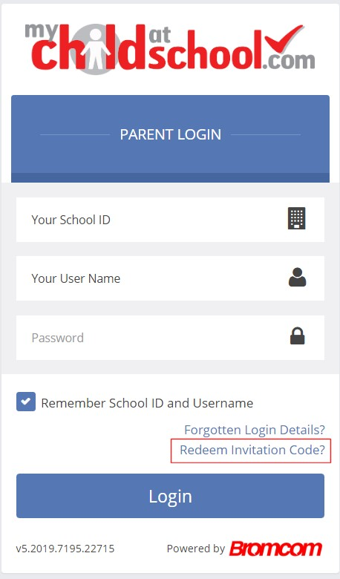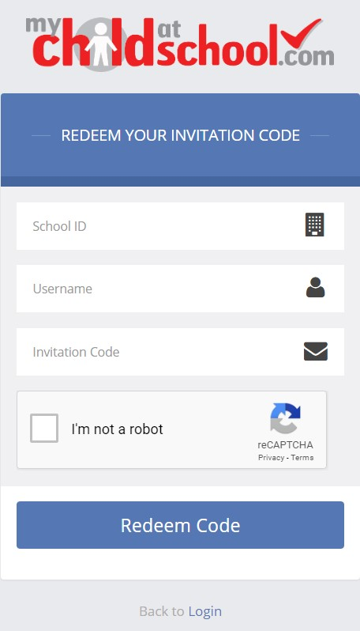
Click on the Redeem Invitation Code? link and enter your School ID, Username and the Invitation Code, which will be a unique 10 character alphanumeric code, [which can only be used once to setup the Account], tick the I’m not a robot box and click on the Redeem Code button.

You will then be asked to Setup your Details, enter the required information to setup the Login Details and click on the Save Account Details button, a message will be displayed that the new Login setup has been successful and you will be returned to the Login page.
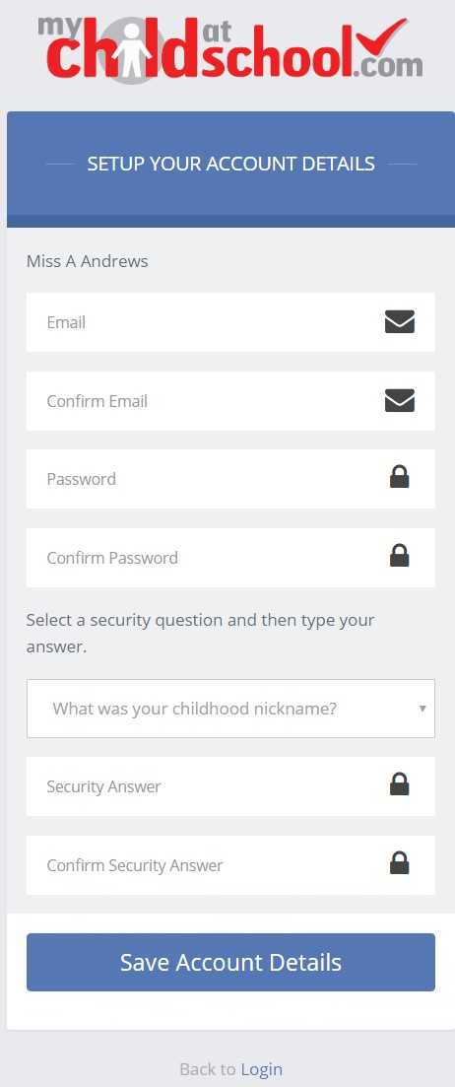
An e-mail will also be sent to the e-mail address entered asking for the Login information to be verified, if this is not verified the you will not be able to Recover Account Details or change the Password in the future.
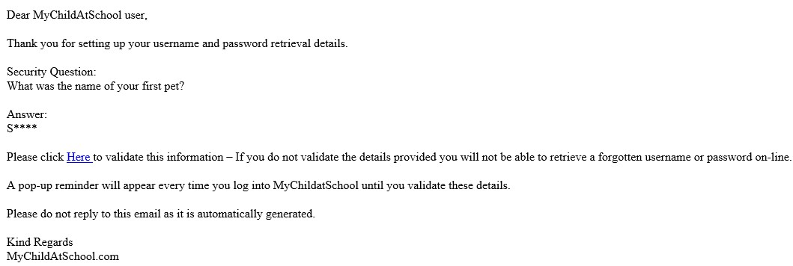
You will now be able to Login using your new Login Details.

If you should forget your Login Information, clicking on the Forgotten Login Details? link will allow you to reset your Password or Recover Account Details.
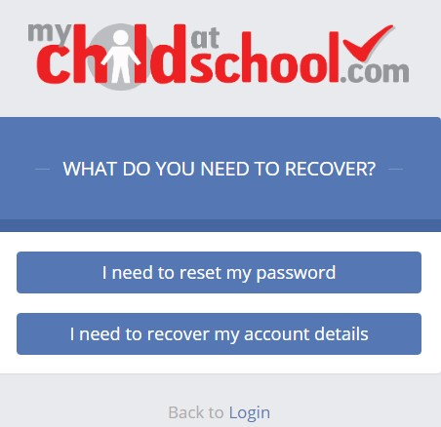

Reset Password
Selecting the I need to reset my password option will open the Reset Password window, where you will be asked to enter the School ID and Email address then click the Send Reset email button.

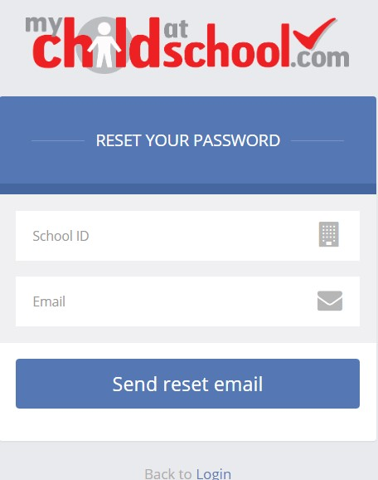
An e-mail will be sent to the verified e-mail address entered, click on the Here link.
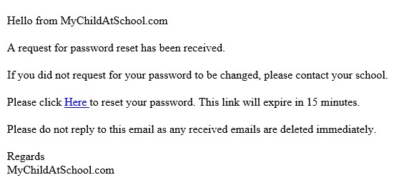

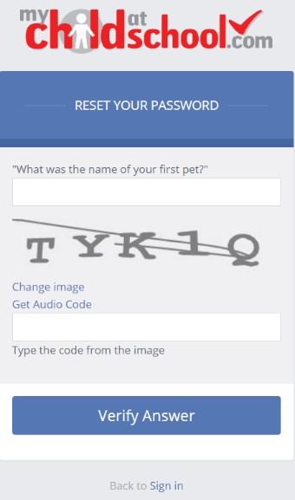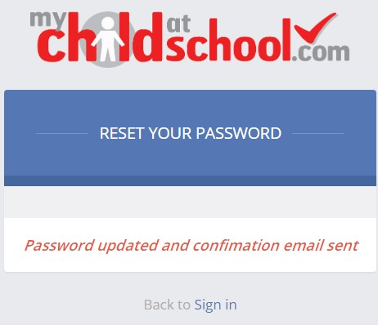
The Security Question set previously will be asked and the Code from the image will need to be entered, then click the Verify Answer button, a new page will show that the requested changes have been made and a confirmation email will be sent.
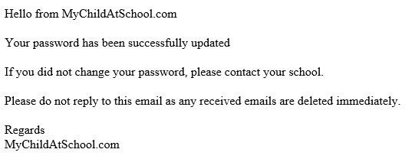

Recover Login Details
Selecting the Recover my login details option will open the Recover login Details window, where you will be asked to enter the School ID and Email address then click the Recover my login details button.

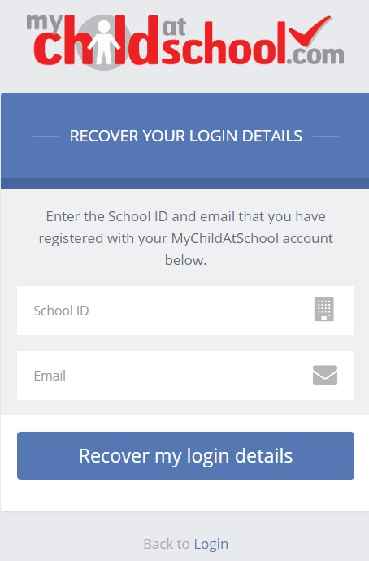
An e-mail will be sent to the verified e-mail address entered with the login name [this will be displayed on the e-mail and not blanked out as in the image].
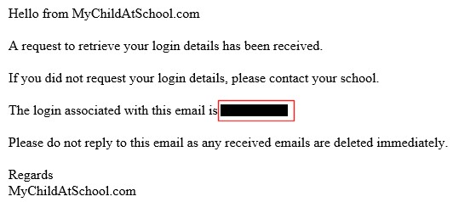

Account Options

On first login to MCAS your Contact Details will be displayed, if they are correct click on the My details are correct button, if they are not click on the Update my details now button and update your Details and Save when finished.

The school set the frequency this option appears, it maybe just once or every 30 or 60 days etc., allowing for new phone numbers or changes to e-mails to be updated.
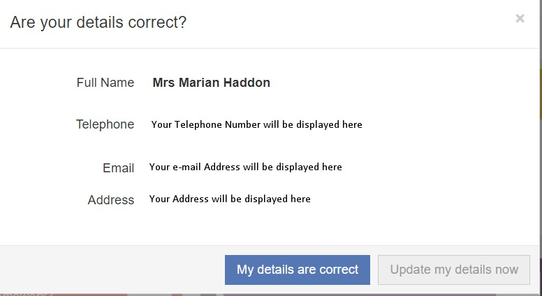
These details can be updated at any time from the Account option, by clicking on the down arrow right of your name and selecting the option from the dropdown menu.
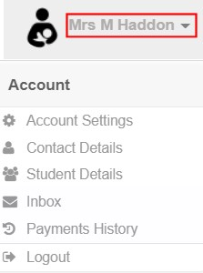
Note: What will be displayed in these options is dependent on the school. Therefore not all of these options may be visible to you.

The Account Settings page contains the Reset Password, e-mail Address (that will be used with MyChildAtSchool) and the Security Details options.
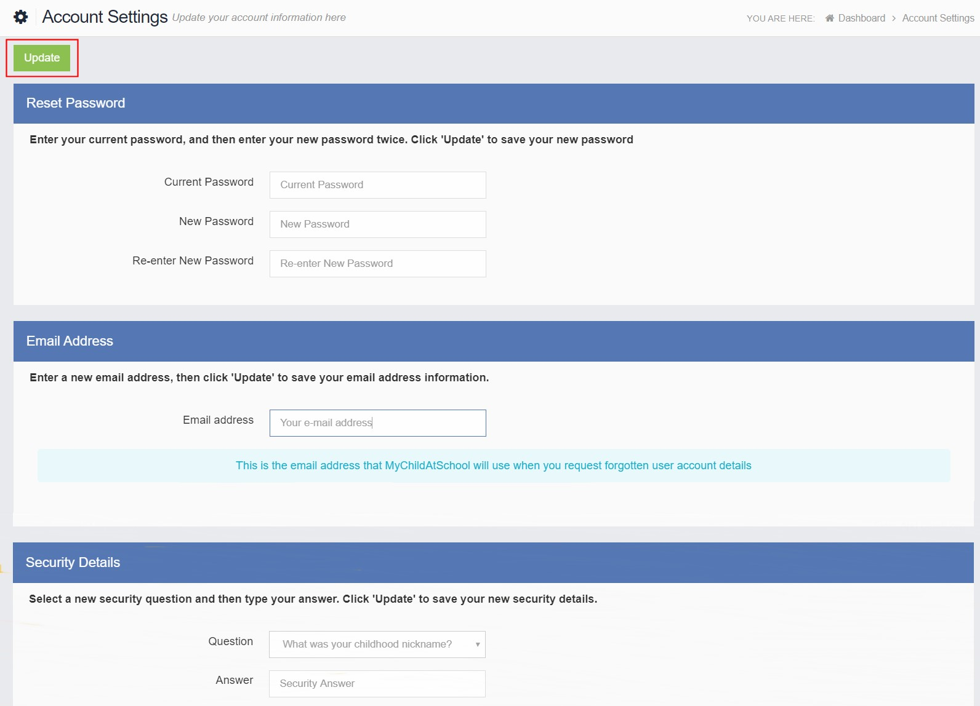
Update the information and click on the Update button to save.

Contact Details page contains the Personal Details of the User.
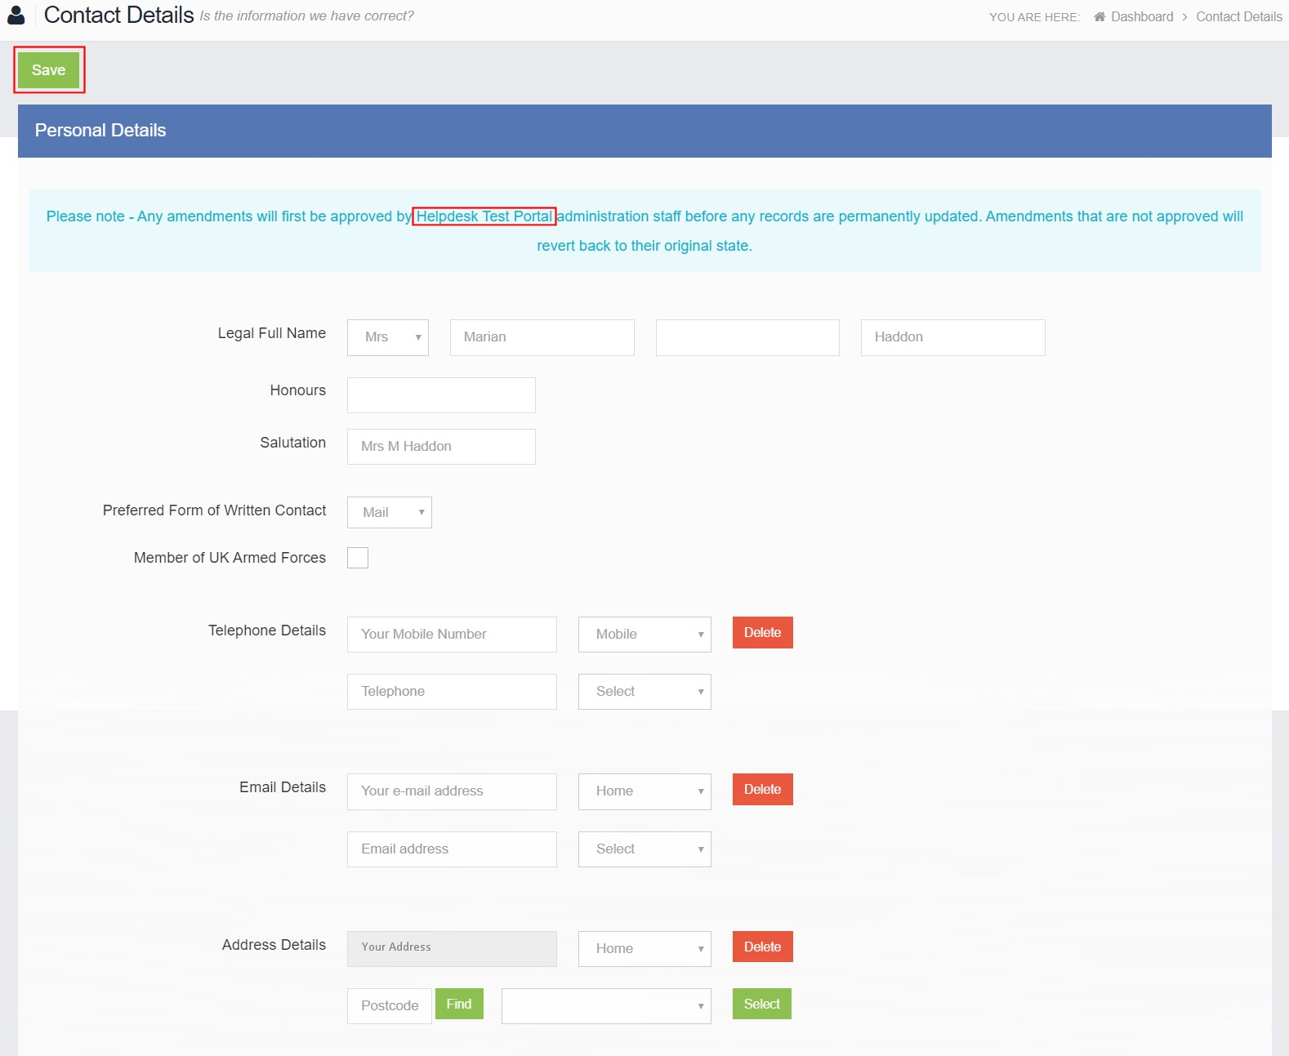
Update the information by using the dropdown menus and the Delete buttons to remove out of date information and click on the Save button to save.

Note: Information edited here is linked to the information held within the school MIS, but will not be updated within the MIS until the school have accepted the changes. If not approved the updated information will revert to its original state.

Note: The Helpdesk Test Portal highlighted at the top of the page is the name of the Database being used for this Guide, the name of the school would be here.

Student Details page contains the Student Details, SEN (Special Educational Needs) and Medical Information.

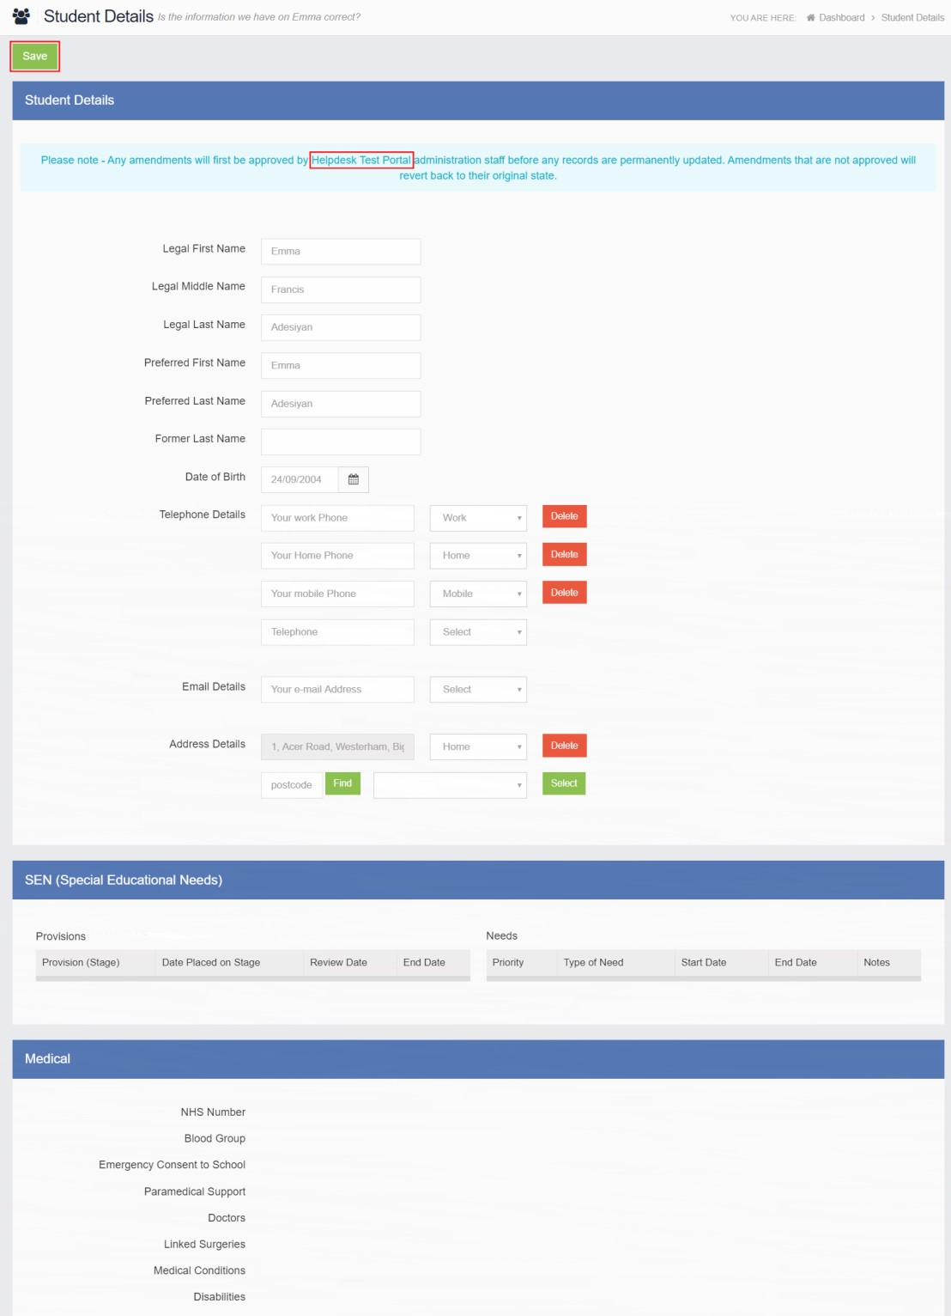
Only the Student Details can be updated, once done click on the Save button to save.

Note: Information edited here is linked to the information held within the school MIS, but will not be updated within the MIS until the school have accepted the changes. If not approved the updated information will revert to its original state.

Note: The Helpdesk Test Portal highlighted at the top of the page is the name of the Database being used for this Guide, the name of the school would be here.

Communication

Inbox page contains any Conversations between the school and the User.
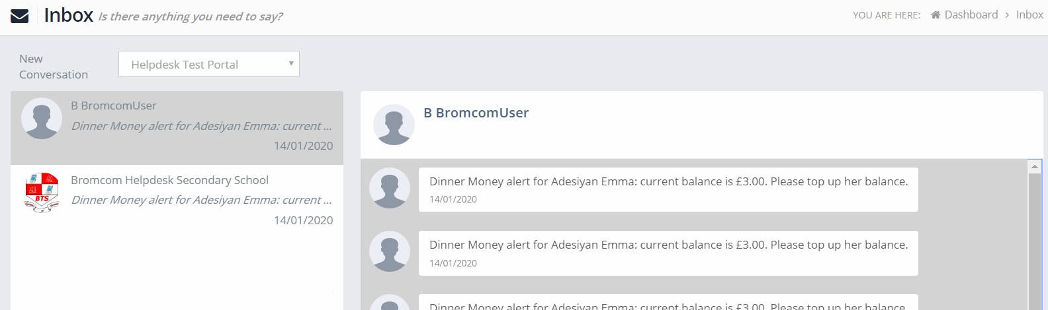
The left panel displays the latest Conversations, clicking on one of these will display the content of the Conversation in the right panel.

To select a Conversation with a particular member of staff, select them from the dropdown list.
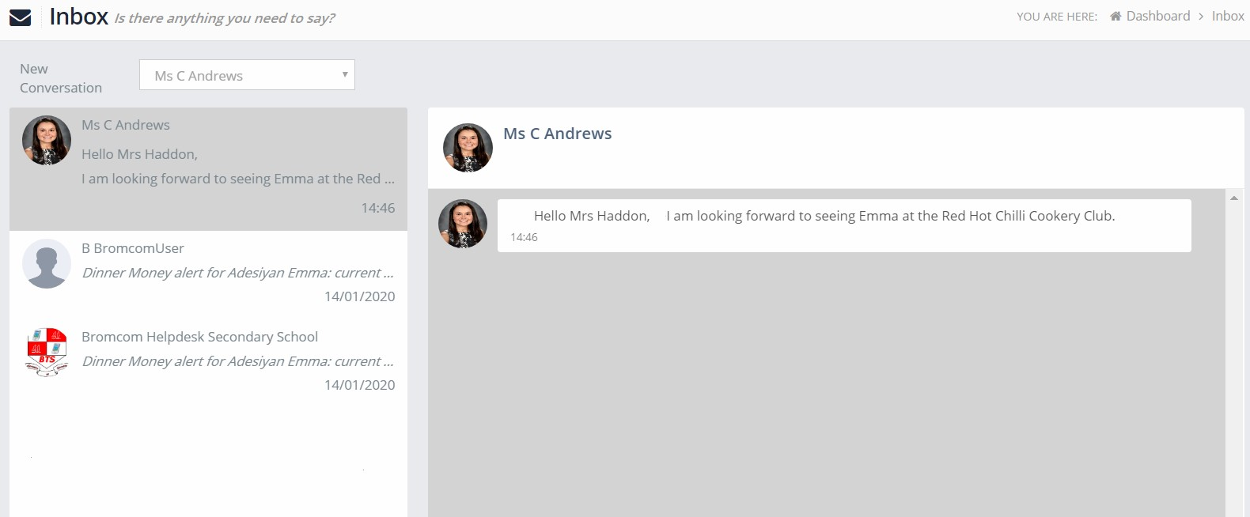
To start a new Conversation with a member of staff select them from the dropdown list and enter your message at the bottom of the page and click on the Flight icon.

You will then be able to follow the Conversation and reply.
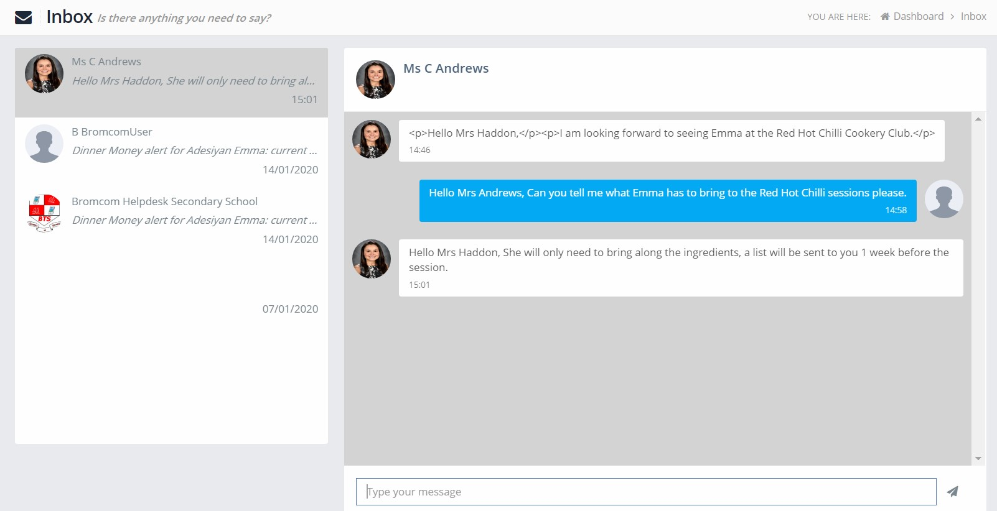
Note: The Helpdesk Test Portal in the dropdown list box is the name of the Database being used for this Guide, the name of the school would be here.

Customising the Pages

The Colour Scheme option allows the Homepage to be customised.

Selecting a colour from the Colour Schemes section will change the colour of the header bars and the text.
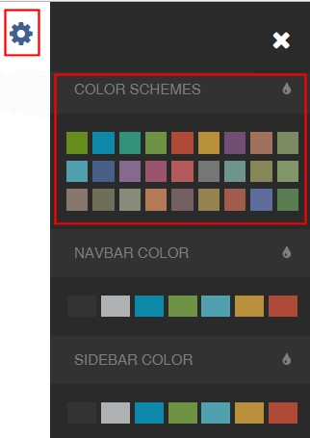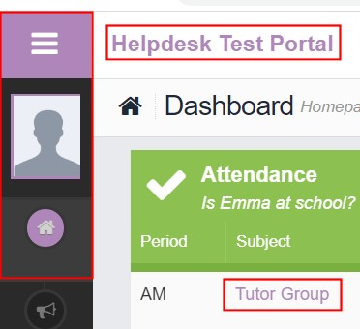
The Navbar Colour option will change the background colour of the Navbar.

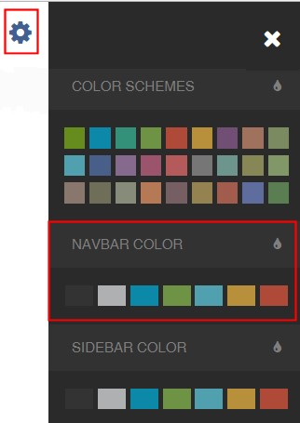
The Sidebar Colour option will change the colour of the Menu Bar.

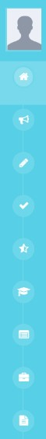
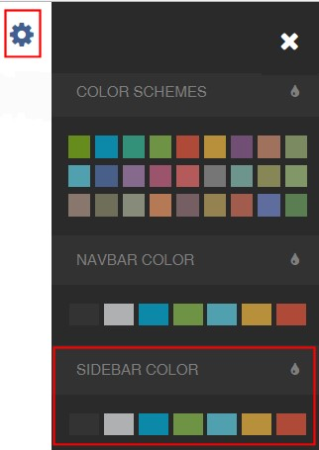

Selecting the MCAS Dashboard

Once you have logged in the Dashboard will be displayed.
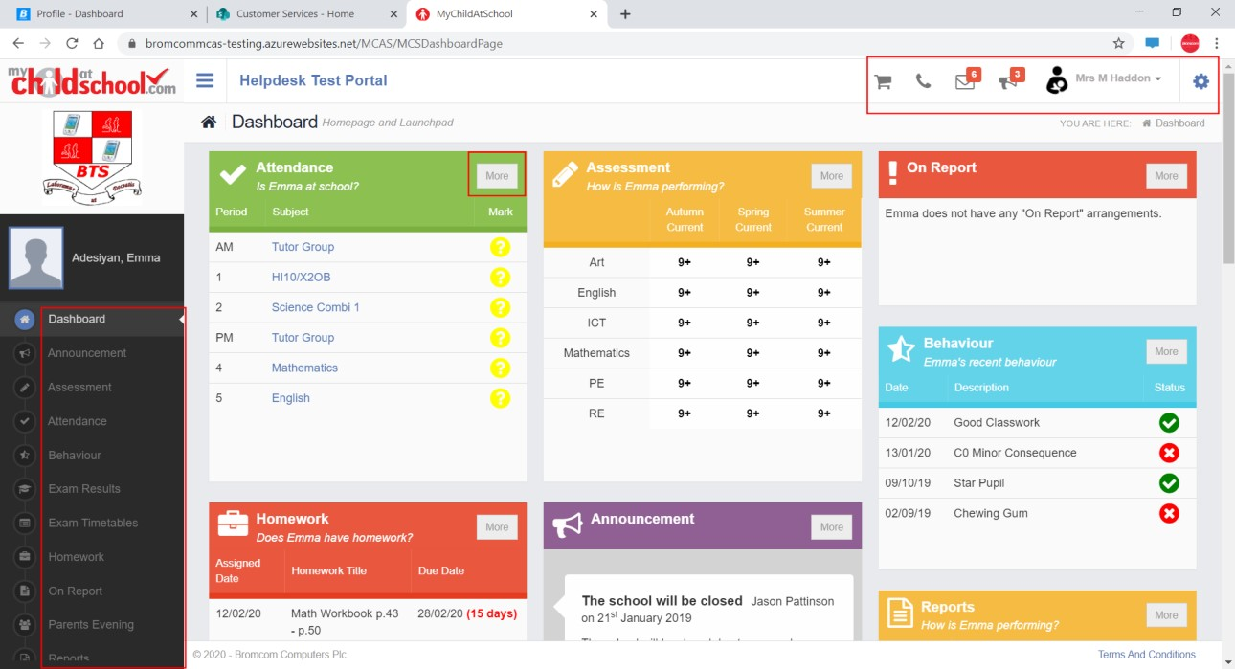
Please Note: What is displayed here is enabled by the school, who may NOT use all of the available options. The school also has configuration options of Colour, Menu Titles and Sub Menu Titles so may differ from the images in this Guide.

Each Widget will display a quick view, clicking on the More button will open that option, giving more detailed information. The Widget options can also be opened from the Menu Bar on the left by clicking on the option.

The Menu Bar also has a scrollbar to the left and can be minimised or maximised by clicking on the Three Bar icon.
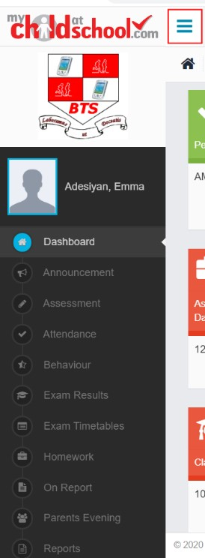

Note: Some of the options are only accessible via the Menu Bar and are not displayed as Widgets.

You will always know where you are within the MCAS Module.
The following options are available and will only be displayed if enabled by the school:

- Academic Calendar  - Announcement  - Assessment  - Attendance  - Behaviour  - Classes  - Clubs & Trips | - Dinner Money  - Dinners  - Dinner Detail • Exam Results  - Exam Timetables  - Homework  - On Report | - Parent Evenings  - Parental Consent • PayPoint Balance  - Reports  - School Shop  - Timetable  - Outstanding Payments

Multiple Students

Clicking on the name of the student, next to the photograph, will open a list of other students associated with the User.

Click on the photograph or the text to change views. Allowing information for more than one associated Student to be viewed without having multiple logins.
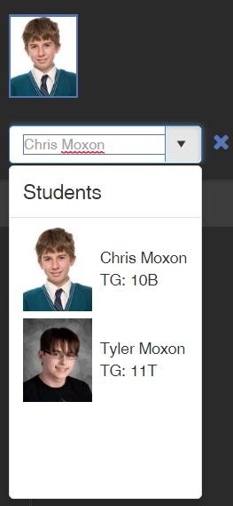

Clubs & Trips
The Clubs & Trips option is accessible from both the Menu Bar and a Widget.
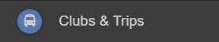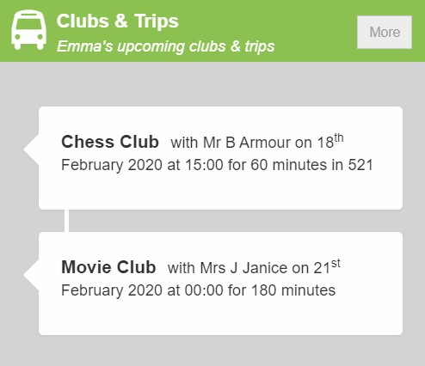

The Widget displays the current Clubs & Trips for the Student and any that are available to be booked.
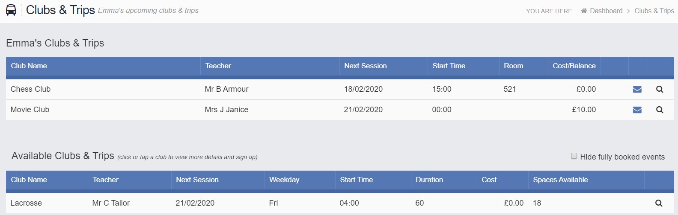
Clicking on a Club in which the Student is already a member will display the details for that Club.
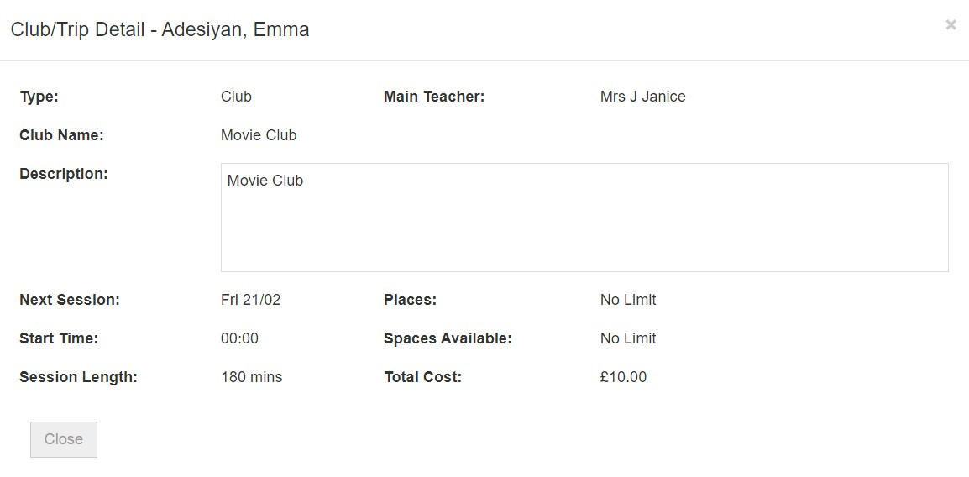

Clicking on a Club that is available will open the booking details
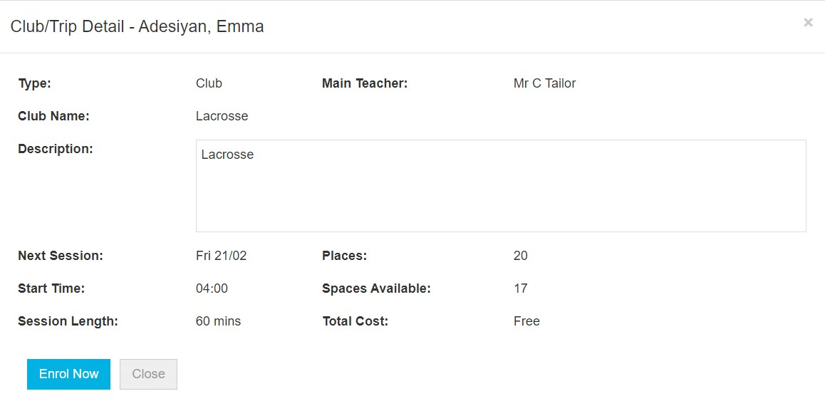
Click on the Enrol Now button, if this is a Free Club the student will be enrolled and this Club added to the current Clubs list. If the Club is to be paid for the amount due will be displayed with an Add to Basket option.

Some Clubs will give the option to select preferred days, to do this click on the days the Student is to attend the sessions, these will display as a green tick in a circle, when finished click on the Enrol button.
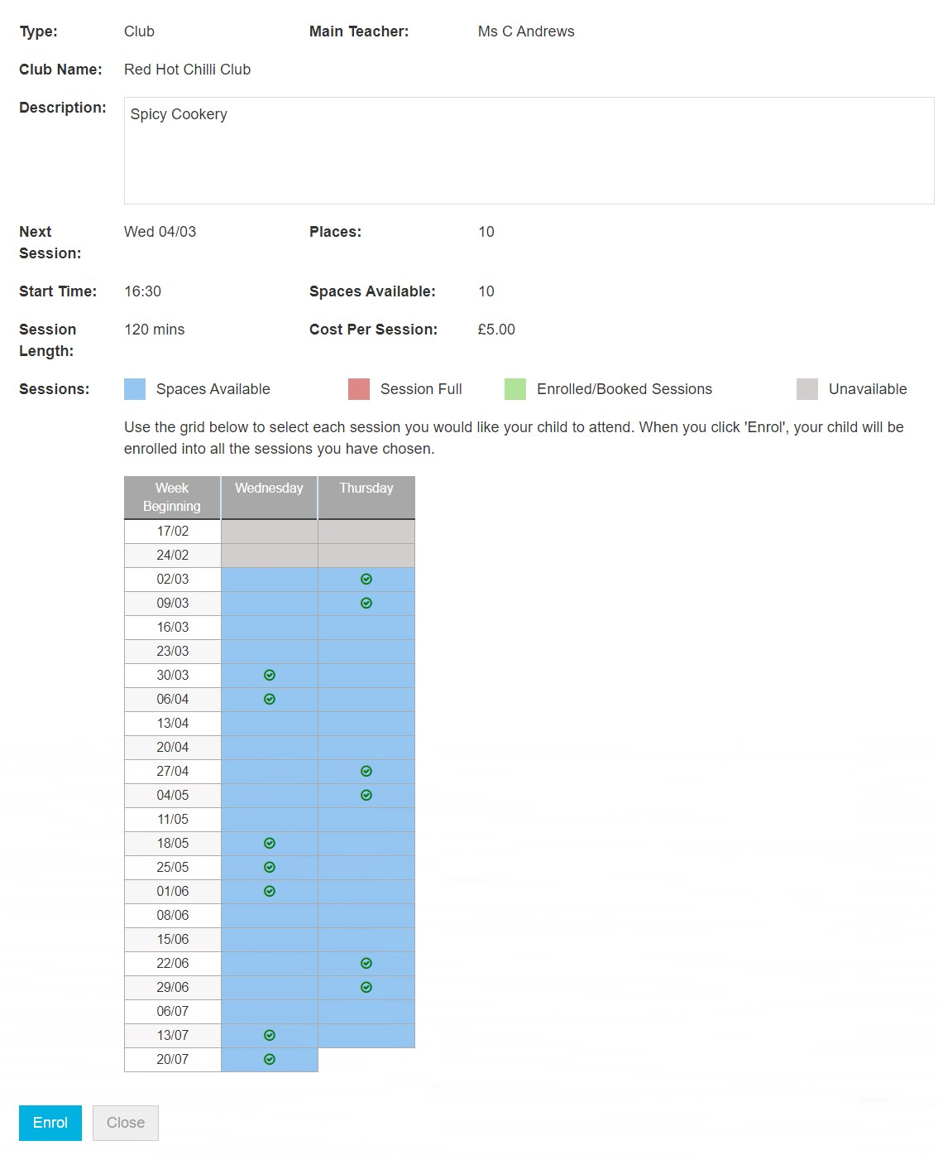

A Confirmation message will be given, click on the Proceed button to continue, the Club will then be added to the current Clubs section with the amount to be paid. Click on the Add to Basket button and pay for this in the normal way.
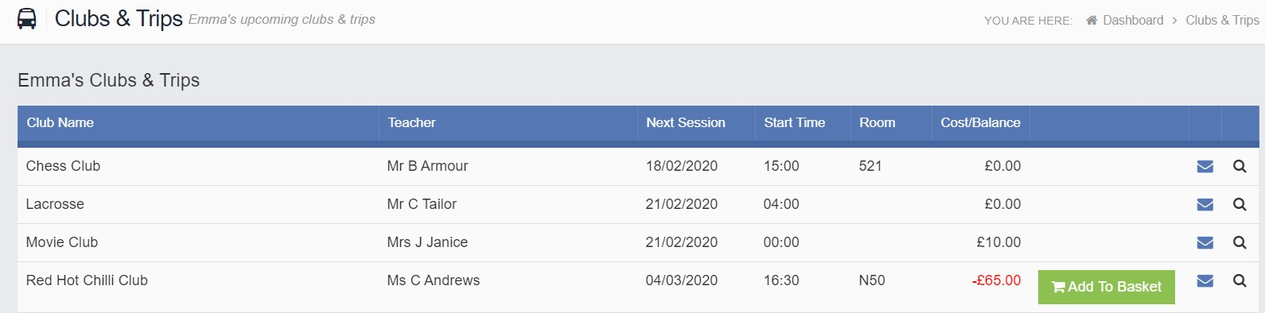

Dinners
The Dinners option is accessible from both the Menu Bar and a Widget.
The Dinner Detail Widget, displays the last Meals that have been taken.
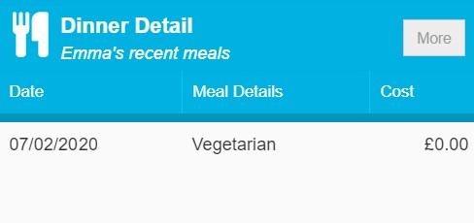
Clicking on the More button will display the last Meals taken and the Dinner Money Payment Details.
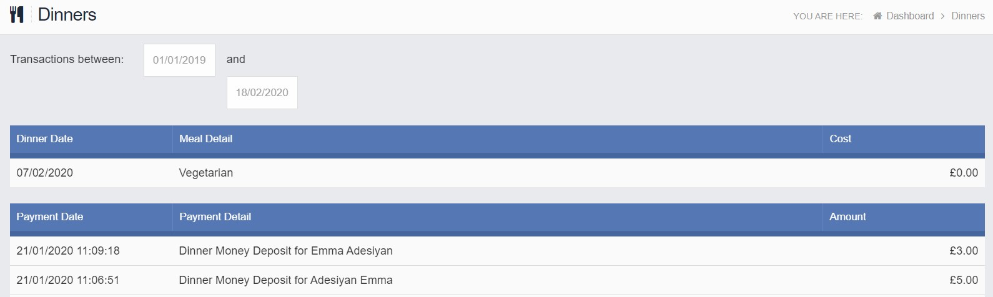

Dinner Money
The Dinner Money option is accessible only as a Widget.
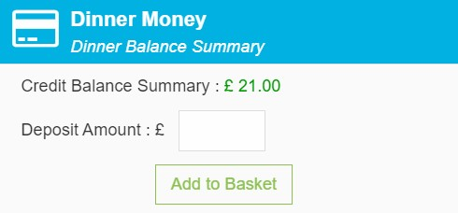
The Widget displays the current Credit Balance Summary and gives the option to top-up the Balance.

To do this enter the amount in the Deposit Amount box and click the Add to Basket button. The Shopping Basket icon on the top bar will now display that you have 1 item in the Basket, click here to open the Basket and view the contents, the item can be removed by clicking on the X to the right.
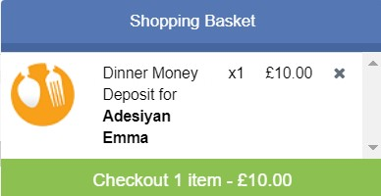
To continue click on the green Checkout bar at the bottom to page, which will open the Shopping Basket. Here you can click the Continue Shopping button to open the School Shop and add more items, the Clear Basket button to empty the Basket or the Checkout button to continue and make your payment.
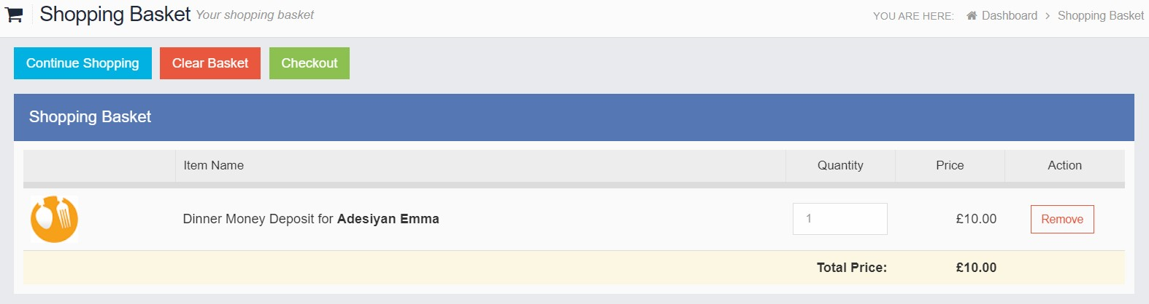
Enter your Payment Details on the following page, once verified and paid a Confirmation message will be given and the Credit Balance Summary updated on the Widget.
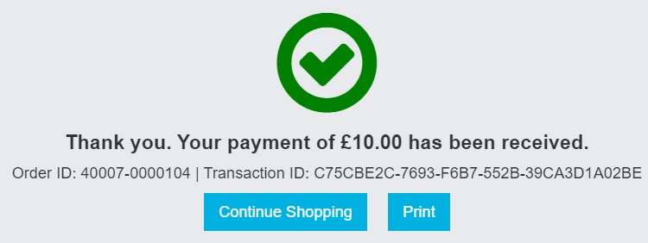

PayPoint
The PayPoint option is accessible only as a Widget.
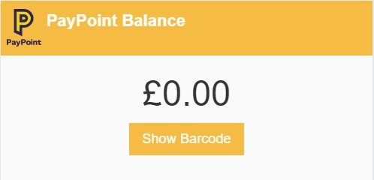
The Widget displays the current PayPoint Balance, clicking on the Show Barcode button will display the Barcode allowing this option to be setup and used by PayPoint Users.

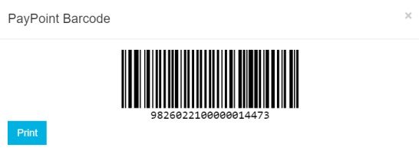

Outstanding Payments
The Outstanding Payments option is accessible only from the Menu Bar and a Widget.
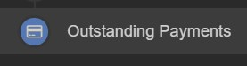
When items have been purchased from the School Shop and there is an outstanding amount, for instance a payment in Instalments, this will be displayed on the Outstanding Payments Widget.
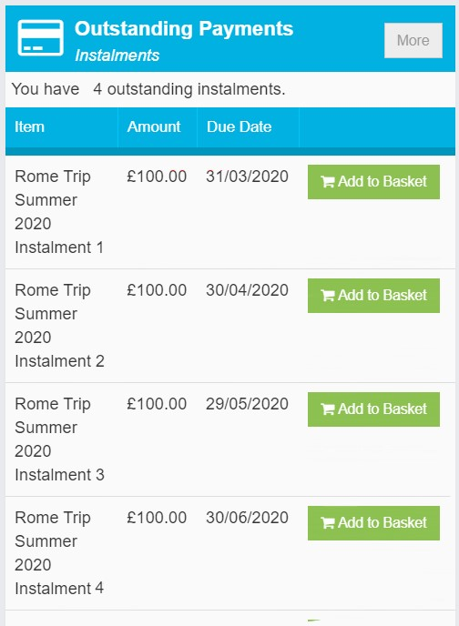
Clicking on the More button will display the full details. An Instalment can be paid by clicking on the Add to Basket button on either page, this can then be paid in the normal way.
