Existing policies and guidance continue to apply alongside the actions within this document, including but not limited to:
Version 4.0
  - Health and Safety Policy
  - First Aid Policy
  - Safeguarding & Child Protection Policy
  - Outbreak Response Plan
  - Living with Covid-19 February 24th 2022 and the School Guidance
  - Reporting of Injuries, Diseases and Dangerous Occurrences Regulations (RIDDOR) 2013 (to be reported via oneSource accident reporting
procedures)
  - The Health Protection (Notification) Regulations 2010
  - Public Health England (PHE) (2017) ‘Health protection in schools and other childcare facilities’
The following workplace controls remain unchanged: · adequate ventilation · sufficient cleaning · good hand hygiene

RISK ASSESSMENT FORM

Assessors name: Joanna Bray/Lisa Davies/Jade Caton/Jacquie Bashford | Date of Assessment: 1/04/ 2022 | Activity/Task: Response to the Government paper- Living with Covid-19 February 24th 2022 and the changes made by government on the 1st April 2022
Directorate: Education | Service: Thameside Primary School  Group: Schools | Headteacher: Joanna Bray

Hazards | Who may be harmed & How | Existing Controls | Risk Rating | Further Controls | Residual Risk | Actions by whom & when | Implemented  Y/N
Exposure to COVID-19 | Anyone exposed to the virus or an infected person may contract Covid-19 potentially resulting in a range of health outcomes | Although the government has removed the legal requirement to self-isolate following a positive test. Adults and children who test positive will continue to be advised to stay at home and avoid contact with other people.  In the Osborne Co-operative Academy Trust any staff or pupils with symptoms of a respiratory infection, such as COVID-19 which includes having a high temperature, and you do not feel well enough to go to work/school or carry out normal activities, you are advised to try to stay at home and avoid contact with other people. You can go back to normal activities if you feel well enough to do so and do not have a high temperature. If you do test positive for COVID19 then you should try and stay home and avoid contact with other people for 5 days.  If a child or young person aged 18 or under tests positive for COVID19, they should try and stay at home and avoid contact with other people for 3 days. This starts form the day after they did the test.  Each setting has a small number of LFTs, where a member of staff is concerned they could be offered one LFT test to be taken in school to confirm Covid status. The same could be offered to a parent concerned about their child, in each case the one test should be taken in school.  Air cleaning units should continue to be used where CO2 monitors report continuous high readings. | Likelihood: 3  Consequence: 2  Risk Level:6 | Reiterate and reinforce all COVID-secure measures, incl. handwashing, cleaning, ventilation of enclosed spaces,  Remind all staff, including new staff of the training available.  If you have symptoms or have a positive COVID-19 test result and you need to leave your home, wearing a well-fitting face covering or a face mask can help reduce the spread of COVID-19 and other respiratory infections. See further advice in the guidance for people with symptoms of a respiratory infection or a positive test result. | Likelihood: 3  Consequence: 2  Risk Level:6 | SLT  All staff | Y
Virus entering premises | Staff, Students & Contractors and their families. | Whilst the guidance states we no longer ask fully vaccinated close contacts and those under the age of 18 to test daily for 7 days, and the legal requirement for close contacts who are not fully vaccinated to self-isolate has been removed, we will ask staff and pupils to be vigilant of symptoms of a respiratory infection, such as COVID-19, and to take extra care as outlined above regarding hand washing etc.  If staff and students wish to wear a mask in school this will be acceptable but is not a requirement of the school risk assessment. | Likelihood:4  Consequence: 2  Risk Level:8 |  |  | SLT  All Staff | Y
Increased contagion across the school – Leading to widespread outbreaks and staff shortages | Staff/students | Schools will manage local outbreaks of COVID-19 as they do with other respiratory infection, inform parents to be vigilant and ensure cleaning regime is adhered to and there is good ventilation maintained in the learning areas.  Inform the Trust if :  • evidence of severe disease due to COVID-19, for example if a pupil, student, or staff member is admitted to hospital due to COVID-19  • a cluster of cases where there are concerns about the health needs of vulnerable staff or students within the affected group  Settings can seek public health and operational advice by phoning the DfE helpline (0800 046 8687, option 1), or ring Thurrock PH Team on 01375 652510  Respiratory hygiene The ‘catch it, bin it, kill it’ approach continues to be very important. The e-Bug COVID-19 website contains free resources for you, including materials to encourage good hand and respiratory hygiene | Likelihood:4  Consequence: 2  Risk Level:8 |  |  | SLT  All Staff | Y
Surface transfer | Staff, Students & Contractors | Cleaning schedule in place and visually displayed with timings of completion and which details all items/areas to be cleaned/sanitized/disinfected and the frequency.  Method statements to be used for each item of equipment. This includes  - Product to be used;  - Method of application; including dwell time;  - Cleaning order;  - Disposal of product;  - PPE.  Enhanced clean will be focused on the area once an outbreak has been advised.  Regular cleaning of high traffic areas e.g. handles, hand rails, toilet areas  UKHSA has published guidance on the cleaning of non-healthcare settings. | Likelihood:3  Consequence: 2  Risk Level:6 |  |  | Site team | Y
Ventilation | Staff, Students & Contractors | Co2 monitors to be monitored regularly in teaching spaces, with measures increased to enable reduction of measurements.  High level windows are encouraged to be kept open in all spaces across the school, low level windows in classrooms could be opened prior to the start of class, and then in ten minute intervals throughout the day including at break and lunchtimes.  Small spaces should limit the number of adults, this is signposted on the door | Likelihood:3  Consequence: 2  Risk Level:6 |  |  | Site staff  All staff | Y
Review date: Date communicated to staff:

Is a safe system of work required Yes / No
If a new activity/equipment/any changes have been identified then Risk Assessment must be reviewed otherwise it should be reviewed annually.
Risk Matrix

The matrix below is designed to help you in identifying a risk level for a given task or activity. Using your experience, the available evidence and existing precautions/ control measures in place you will have already determined the consequence of harm, and the likelihood of the harm being realised. The level of risk for the respective task or activity can now be determined using the following matrix.

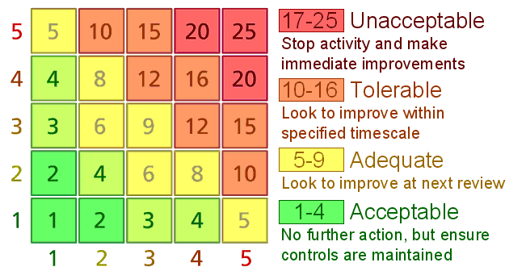
Very unlikely
Unlikely
Fairly likely
Likely
Very likely
Catastrophic
Major
Moderate
Minor
Insignificant

